**Assignment 3**

**Name – SURAJ KUMAR YADAV**

**ROLL NO. – 20220PHY014**

1. **Half Subtractor**
   1. Subtract 1 and 1

Let x = 1 and y = 1

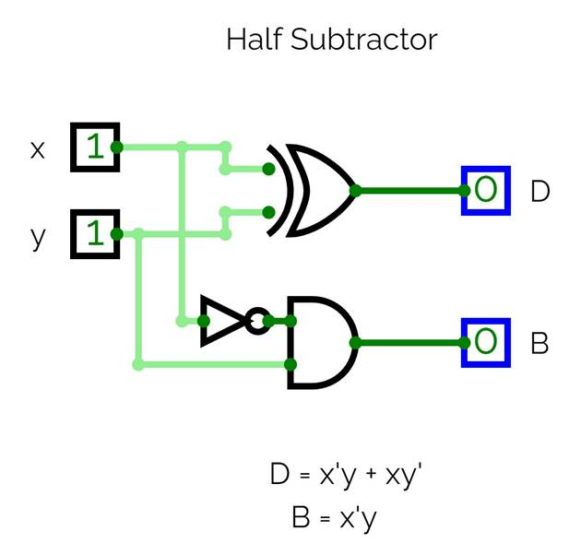

* 1. Subtract 1 and 0

Let x = 1 and y = 0

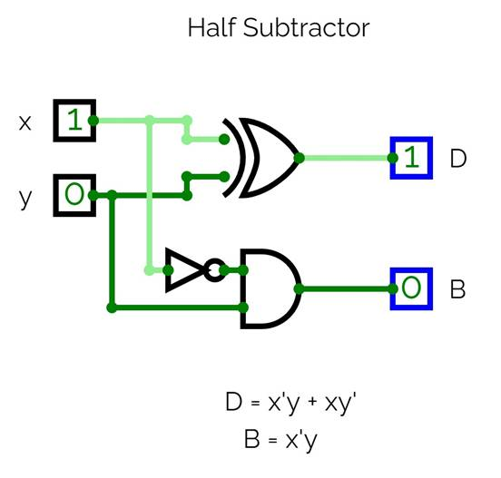

1. **Full Subtractor**
   1. Subtract 1, 1, 0

Let x = 1, y = 1, z = 0

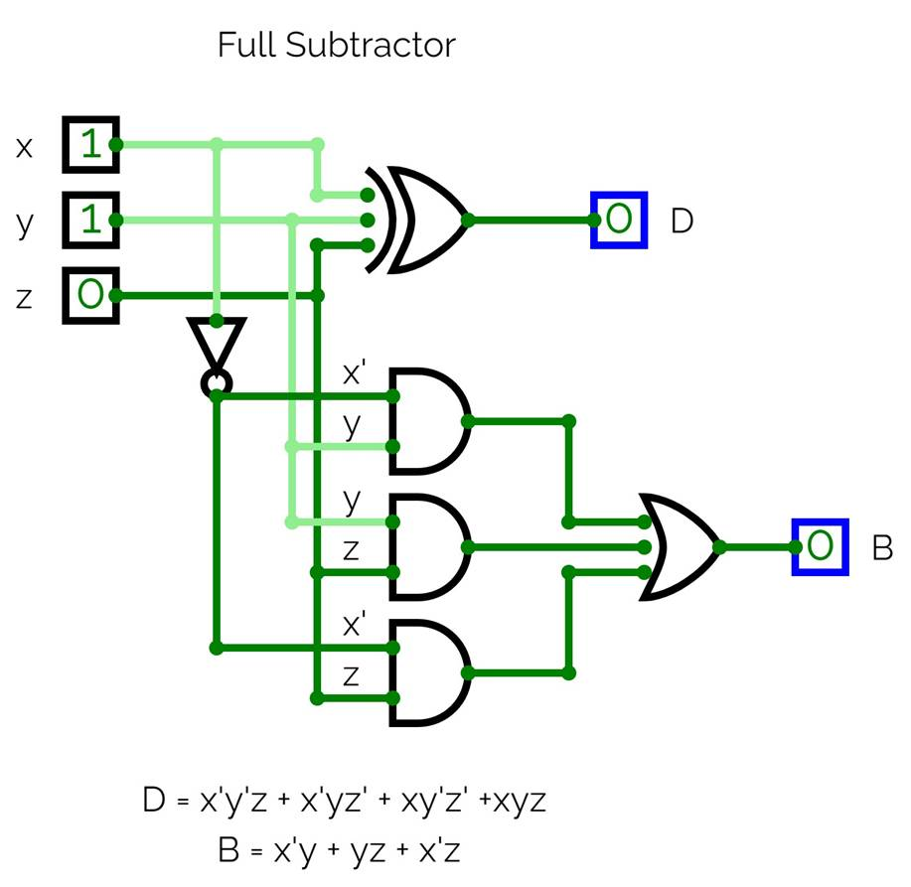

* 1. Subtract 1, 0, 0

Let x = 1, y = 0, z = 0

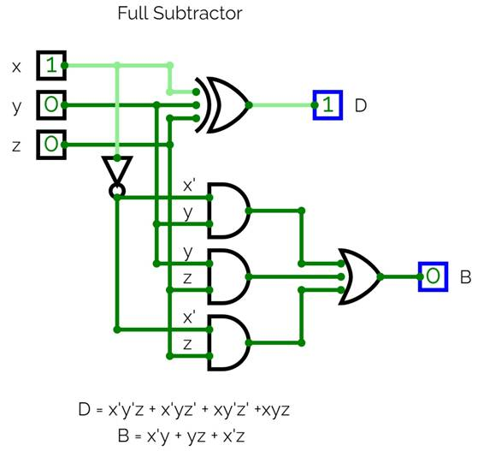

1. **Binary parallel adder**
   1. Add 1001 + 1100

Let A = 1001 and B = 1100

Here, A1 = 1, A2 = 0, A3 = 0, A4 = 1

And B1 = 0, B2 = 0, B3 = 1, B4 = 1

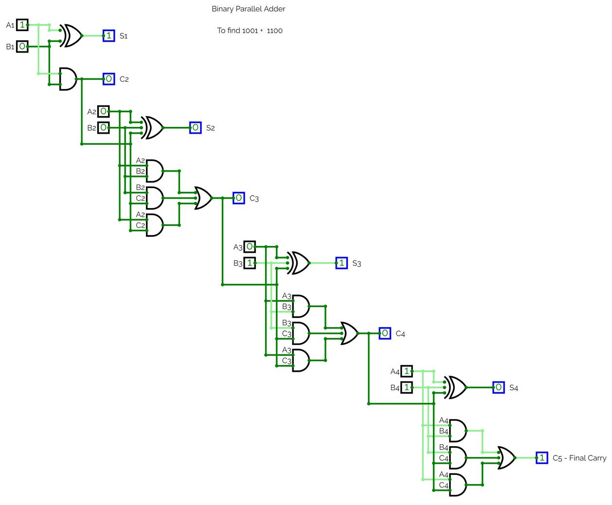

* 1. Add 1111 + 1010

Let A = 1111 and B = 1010

Here, A1 = 1, A2 = 1, A3 = 1, A4 = 1

And B1 = 0, B2 = 1, B3 = 0, B4 = 1

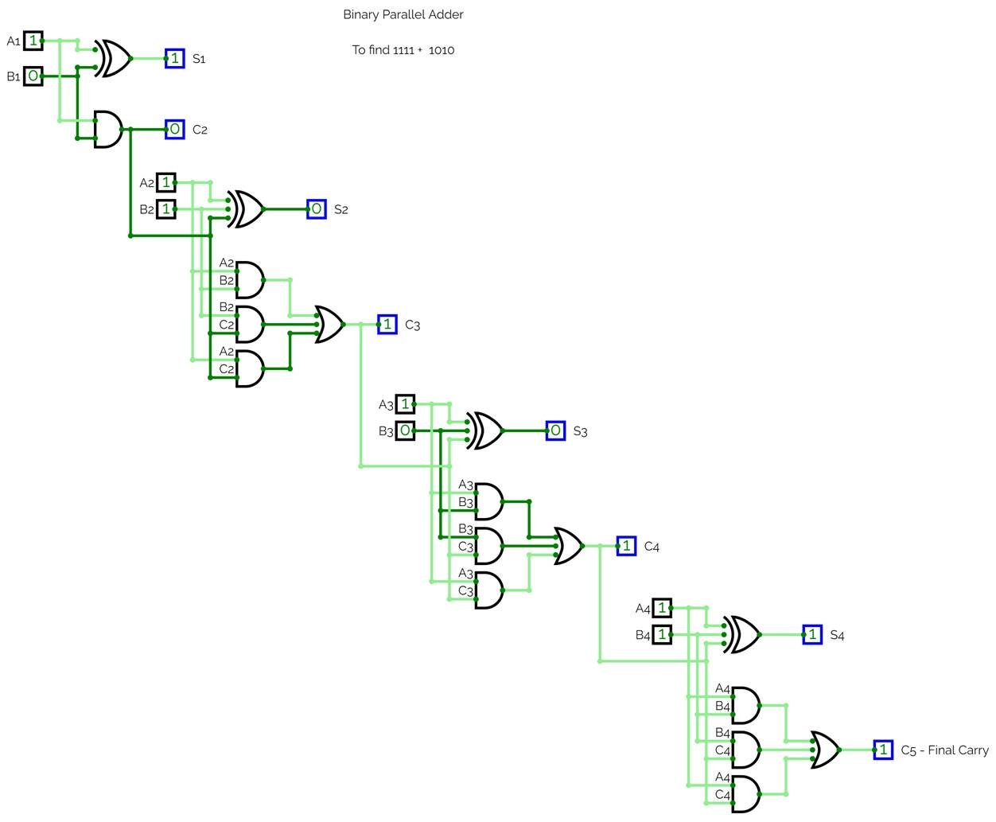

1. **4 bit Magnitude Comparator**
   1. Compare 1101 & 1100

Let A = 1101 and B = 1100

Here, A1 = 1, A2 = 0, A3 = 1, A4 = 1

And B1 = 0, B2 = 0, B3 = 1, B4 = 1

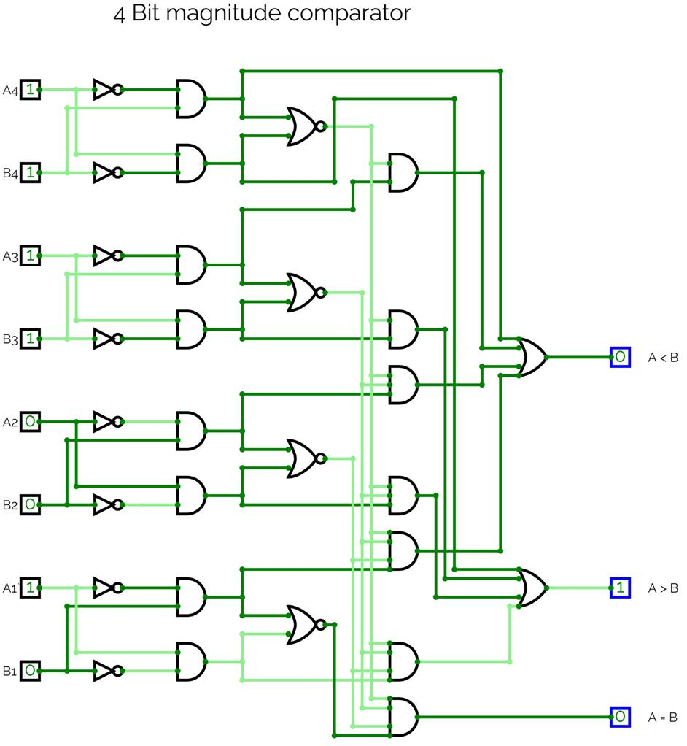

* 1. Compare 1000 & 1000

Let A = 1000 and B = 1000

Here, A0 = 0, A2 = 0, A3 = 0, A4 = 1

And B1 = 0, B2 = 0, B3 = 0, B4 = 1

